Evil number

Opposite

Odius number

Intro

An evil number is a non-negative integer that has an even [number of 1s](https://en.wikipedia.org/wiki/Hamming_weight) in its [binary expansion.](https://en.wikipedia.org/wiki/Binary_number) Take the number $$0_{\left(10\right)}$$ for example.

Since $$0_{\left(10\right)}$$ in decimal number is represented as $$0_{\left(2\right)}$$ which has 0 number of 1.

Example

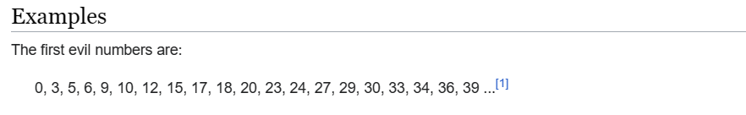

|  |  |
| --- | --- |
| $$0_{\left(10\right)}$$ | $$0_{\left(2\right)}$$ |
| $$3_{\left(10\right)}$$ | $${11}_{\left(2\right)}$$ |
| $$5_{\left(10\right)}$$ | $${101}_{\left(2\right)}$$ |
| $$6_{\left(10\right)}$$ | $${110}_{\left(2\right)}$$ |

Ref

[Evil number - Wikipedia](https://en.wikipedia.org/wiki/Evil_number)